### 实战七 Web前端综合实战之（一）

**学生姓名： 王建峰 班级：     软件182       学号：   201859065223**

**实验地点：      9号楼105      指导教师：     桑高丽**

**实验日期：     2021/4/15    实验环境：     window10    + editplus**

#### 一、实验目的

利用HTML、CSS和JavaScript技术设计幸福西饼所要求的模块初始页面。

#### 实验内容和要求

要求设计幸福西饼网站首页，具体要求如下。

1. 导航栏部分，鼠标移过来有状态改变（JavaScript实现）
2. 中间主体部分，轮播显示（JavaScript实现）。
3. 产品分类展示部分，鼠标移过来有状态改变（JavaScript实现）
4. 网站footer按页面显示实现。

网站整体效果图如下：

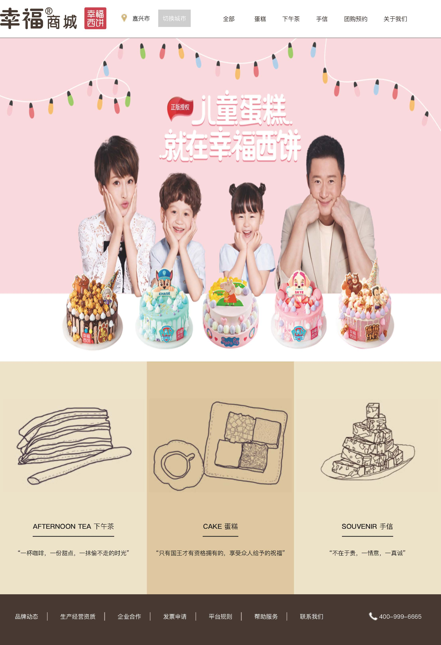

<!DOCTYPE html>

<html>

<head>

<meta charset="utf-8" />

<script src="js/jquery.js" type="text/javascript" charset="utf-8"></script>

<title></title>

<style type="text/css">

.change {

background-color: red

}

.normal {

background-color: white

}

ul {

list-style-type: none;

1/删除无序列表的项目符号

}

.ull li {

display: inline;

1/横向排序

}

a {

text-decoration: none

}

a:link {

color: black

}

a:visited {

color: black

}

a:hover {

color: black

}

a:active {

color: black

}

</style>

</head>

<body>

<div id="" style="width: 20%; float: left;">

<span id="">

<img src="./img/logo_big01.png" width="200">

</span>

<span id="">

<img src="./img/icon-address.png">嘉兴

</span>

</div>

<div id="" style="width: 80%; float: left;">

<iframe src="index.html" width="100%" height="50" frameborder="0" scrolling="no"

style="padding-left: -150px; padding-right: -200px;"></iframe>

</div>

<div id="">

<iframe src="6.3.html" width="100%" height="800" border="0" scrolling="no"></iframe>

</div>

<div id="" style="width: 100%;">

<div id="" onmouseover="this.style.backgroundColor='#DFC7A1'"

onmouseout="this.style.backgroundColor='#EDE3C8'"

style="width: 30%;height: 300px;background-color: #EDE3C8;float: left; padding: 45px;">

<div id="" style="width: 250px;height: 50px;">

<img src="img/ca-afternoontea.png" width="150">

<font size="4" color="" style="font-weight: bold;">

<p>AFTERNOON TEA|下午茶</p>

</font>

<hr style="background-color: #000000; height: 4px; width: 240px; float: left;">

</font>

<br>

<p>“一杯咖啡，一杯甜点，一抹偷不走的时光”</p>

</div>

</div>

<div id="" onmouseover="this.style.backgroundColor='#DFC7A1'"

onmouseout="this.style.backgroundColor='#EDE3C8'"

style="width: 26%;height: 300px;background-color: #EDE3C8;float: left; padding: 45px;">

<div id="" style="width: 250px;height: 50px;">

<img src="img/ca-cake.png" width="150">

<font size="4" color="" style="font-weight: bold;">

<p>CAKE 蛋糕</p>

</font>

<hr style="background-color: #000000; height: 4px; width: 100px; float: left;">

</font>

<br>

<p>“只有国王才有资格拥有的，享有众人的给予的祝福”</p>

</div>

</div>

<div id="" onmouseover="this.style.backgroundColor='#DFC7A1'"

onmouseout="this.style.backgroundColor='#EDE3C8'"

style="width: 26%;height: 300px;background-color: #EDE3C8;float: left; padding: 45px;">

<div id="" style="width: 250px;height: 50px;">

<img src="img/ca-afternoontea.png" width="150">

<font size="4" color="" style="font-weight: bold;">

<p>SOUVENIR 手信</p>

<hr style="background-color: #000000; height: 4px; width: 160px; float: left;">

</font>

<br>

<p>“不在于贵，一情意，一真诚”</p>

</div>

</div>

</div>

<br>

<div id=""

style="background-color: #473831; width: 100%; height: 100px; clear: both; align-content: center; line-height: 100px">

<ul class="ull">

<li><a href="#" style="margin: 10px;">

<font size="3" color="white">品牌动态</font>

</a></li>

<li><font size="3" color="white">|</font></li>

<li><a href="#" style="margin: 10px;">

<font size="3" color="white">生产经营资质</font>

</a></li>

<li><font size="3" color="white">|</font></li>

<li><a href="#" style="margin: 10px;">

<font size="3" color="white">企业合作</font>

</a></li>

<li><font size="3" color="white">|</font></li>

<li><a href="#" style="margin: 10px;">

<font size="3" color="white">发票申请</font>

</a></li>

<li><font size="3" color="white">|</font></li>

<li><a href="#" style="margin: 10px;">

<font size="3" color="white">平台规则</font>

</a></li>

<li><font size="3" color="white">|</font></li>

<li><a href="#" style="margin: 10px;">

<font size="3" color="white">帮助服务</font>

</a></li>

<li><font size="3" color="white">|</font></li>

<li><a href="#" style="margin: 10px;">

<font size="3" color="white">联系我们</font>

</a></li>

<li></li>

<li></li>

<li><img src="img/tel_03.jpg" ><font size="3" color="white">400-999-6665</font></li>

</ul>

</div>

</body>

</html>

<!DOCTYPE html>

<html lang="en">

<head>

<meta http-equiv="Content-Type" content="text/html; charset=utf-8">

<meta name="viewport" content="width=device-width, initial-scale=1, maximum-scale=1">

<title>实验7</title>

<link href="css/zzsc.css" rel="stylesheet">

<link href="css/maps.css" rel="stylesheet">

<script type="text/javascript" src="js/maps.js"></script>

<script type="text/javascript" src="js/google.js"></script>

<script type="text/javascript">

$(document).ready(function() {

$().maps();

});

</script>

</head>

<body>

<p style="display:none">Lorem ipsum dolor dit amet</p>

<div style="clear:both; margin: -30px; width: 800px;">

<script src="/gg_bd_ad_720x90.js" type="text/javascript"></script>

<script src="/follow.js" type="text/javascript"></script>

</div>

<div class="content">

<ul class="venus-menu">

<p style="display:none">Lorem ipsum dolor dit amet</p>

<li class="active"><a href="#"><i class="icon-home"></i>切换城市</a></li>

<p style="display:none">

Lorem ipsum dolor dit amet</p>

<p style="display:none">Lorem ipsum dolor dit amet</p>

</li>

<li><a href="#"><i class="icon-magic"></i>全部</a></li>

<p style="display:none">

Lorem ipsum dolor dit amet</p>

</li>

<li><a href="#"><i class="icon-thumbs-up"></i>蛋糕</a>

<p style="display:none">Lorem ipsum dolor dit amet</p>

</li>

<p style="display:none">Lorem ipsum dolor dit amet</p>

</li>

<li><a href="#"><i class="icon-quote-right"></i>下午茶</a></li>

<p style="display:none">

Lorem ipsum dolor dit amet</p>

</li>

<li><a href="#"><i class="icon-envelope-alt"></i>手信</a></li>

<p style="display:none">

Lorem ipsum dolor dit amet</p>

</li>

<p style="display:none">Lorem ipsum dolor dit amet</p>

</li>

<li><a href="#"><i class="icon-envelope-alt"></i>团购预约</a></li>

<p style="display:none">

Lorem ipsum dolor dit amet</p>

</li>

<p style="display:none">Lorem ipsum dolor dit amet</p>

</li>

<li><a href="#"><i class="icon-envelope-alt"></i>关于我们</a></li>

</li>

</li>

</ul>

</div>

</body>

</html>

<!DOCTYPE html>

<html lang="en">

<head>

<meta charset="UTF-8">

<title>轮播图实现</title>

<style type="text/css">

.img-slide{

display: none;

}

.img-slide.img1{

display: block;

}

.imgBox{

background-color: aliceblue;

height: 400px;

width: 100%;

align-content: center;

}

</style>

</head>

<body>

<div class="imgBox" onmouseout="start1()">

<img class="img-slide img1" src="img/bg1.jpg" alt="1" width="100%">

<img class="img-slide img2" src="./img/bg2.png" alt="2" width="100%">

<img class="img-slide img3" src="img/bg3.png" alt="3" width="100%">

</div>

</body>

<script type="text/javascript">

var index=0;

var timer = null;

//改变图片

function ChangeImg() {

index++;

var a=document.getElementsByClassName("img-slide");

if(index>=a.length) index=0;

for(var i=0;i<a.length;i++){

a[i].style.display='none';

}

a[index].style.display='block';

}

//设置定时器，每隔两秒切换一张图片

function start1(){

console.log("start");

if(timer == null){

timer = setInterval(ChangeImg,2000);

console.log("create ");

}

}

function pause1(){

console.log("pause");

clearInterval(timer);

timer = null;

}

</script>

</html>

